**The purpose of this document is to showcase and capture key aspects of the configuration and setup within my lab environment.**

Finance01 pc can successfully browse the **intranet** hosted on **AT-SVR01** (VLAN 60), which shows that the VLANs are correctly routing between the finance department and the internal servers.

Figure 1: Intranet access from Finance

Guest01 PC (VLAN 40) can ping the internet (e.g., Google DNS) but cannot access internal network resources, as expected. This indicates the correct isolation of the guest network from the internal network.

Figure 2: Guest is not able to access internal network but able to access the internet

This screenshot shows Sales01 PC (VLAN20) can browse to the Internet (sample google page) which resides outside of the office router.

Figure 3 :Sales dept browsing the Internet

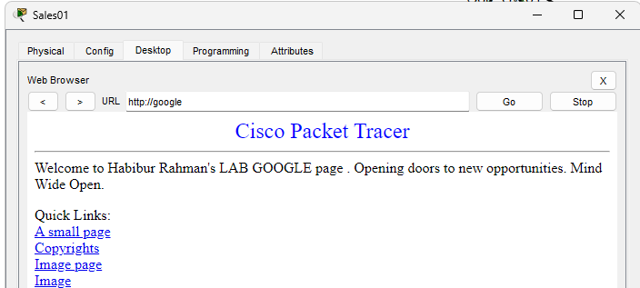

Admin02 PC (VLAN 10): can successfully ping to Google from the admin department (VLAN 10), verifying proper internet connectivity same as all other VLANs

Figure 4: ping success from admin department (VLAN10) to the internet (Google)

NAT Traffic on Edge Router the packet capture shows that traffic from internal VLANs (Sales Figure 3 and Admin Figure 4) is being translated by the edge router for external internet access, confirming that NAT (Network Address Translation) is functioning as expected.

Figure 5: NAT Traffic captured on Edge router

SYSLOG Capture on AT-SVR01, logs from the SYSLOG server show that network events and traffic from the Core_SW02 (10.10.60.3) & Core_SW01 (10.10.60.2) are being captured, which aids in troubleshooting and monitoring.

Figure 6: Logs from the SYSLOG server

SSH to Core Switch (IT_admin01 PC) SSH access from an IT admin PC to the core switch, indicating proper configuration for administrative access.

Figure 9: SSH to Core switch

